Laporan Keuangan Jaga Malam
Periode Bulan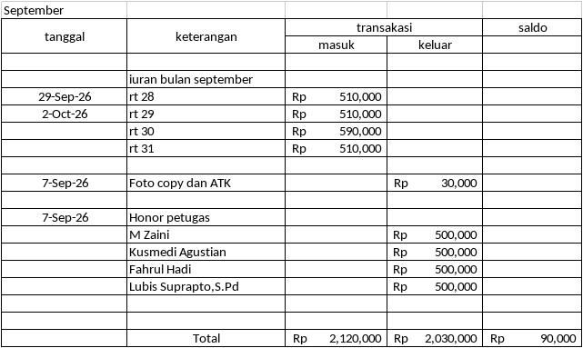
Note:

Sembawa,..........................2026

Sekretaris | Bendahara | Mengetahui,
Nanda Arieski,S.Pd | Ny. Darsiah | Muhammad Fajrin Saputra,S.Kom

TANDA TERIMA HONOR
Nomor: ................................

Telah dibayarkan honor kepada penerima sebagaimana daftar berikut:

No. | Nama Penerima | Tanggal | Besaran Honor | Tanda Tangan
1 | ........................................... | ................................................ | ................................... | ................
2 | .......................................... | .............................................. | ................................... | ................
3 | .......................................... | .............................................. | ................................... | ................
4 | .......................................... | .............................................. | ................................... | ................
5 | .......................................... | .............................................. | ................................... | ................
6 | .......................................... | .............................................. | ................................... | ................
7 | .......................................... | .............................................. | ................................... | ................
8 | .......................................... | .............................................. | ................................... | ................
9 | .......................................... | .............................................. | ................................... | ................
10 | .......................................... | .............................................. | ................................... | ................

Total Honor: Rp ................................................
Terbilang: ...............................................................................................
Sembawa, ........................ 20....

Diserahkan Oleh
Bendahara
Ny. Darsiah

